IS201 Fundamentals of Computing
HOS06 Working with Files
10/01/2024 Reviewed by Ashwin Paturi
06/13/2025 Revised by Scott Zhou
10/30/2025 Reviewed by Honorine Ndom Ndzah
12/16/2025 Reviewed by Megha Narendra Simha

School of Technology & Computing (STC) @City University of Seattle (CityU)


Before You Start
- The directory path shown in screenshots may be different from yours.
- Some steps are not explained in the tutorial. If you are not sure what to do:
  - Consult the resources listed below.
  - If you cannot solve the problem after a few tries, ask a TA for help.

Learning Outcomes

- Understand basic file operations with Python.
- Learn to iterate over the file’s content line by line.
- Learn how to perform file operations like renaming and deleting files.
- Learn how to handle exceptions that might occur during file operations.

Resources

- Matthes, E. (2023). Python Crash Course: A Hands-On, Project-Based Introduction to Programming, 3rd Edition. No Starch Press. (ISBN 9781098156664)

Create a Project

Follow HOS1 to set up the project in Codespaces, or use any other code editor you prefer, such as Visual Studio, Visual Studio Code, Sublime, Vim, etc…

We will create a Python project to cover all the learning outcomes.

- Create a Python file named HOS06.py
- Import path from pathlib.

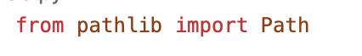
- Create a function to read the files and try except to create a new file if the file was not found.
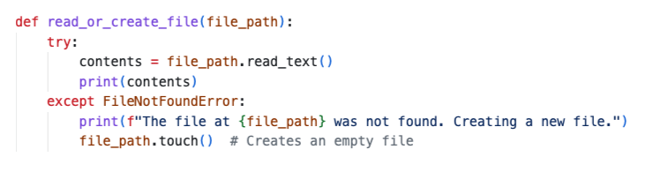

- Create a function to read files line by line.
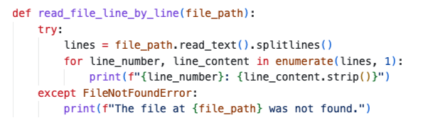
- Create a function to rename the file and add an exception if the file does not exist or any other possible error.

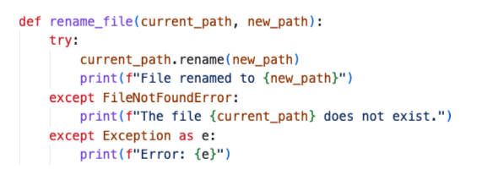
- Create a function to delete files and apply the same exceptions to handle if the file does not exist or any other possible error.

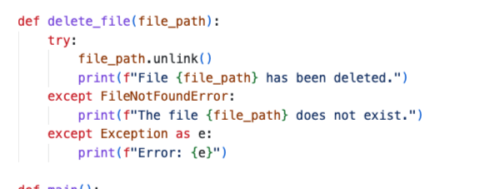
- Add the main function to test all the functions we just created.

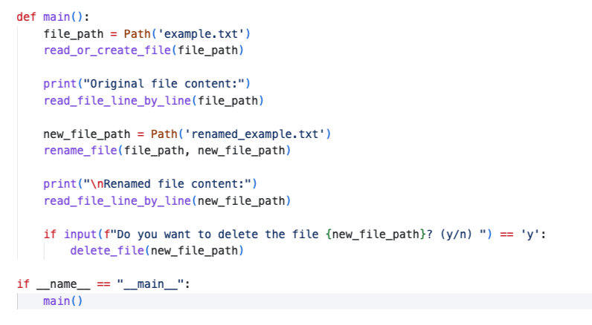

- Execute the program, the program will create the example.txt file since it does not exist and then follow the program logic to rename the file to renamed_example.txt. The terminal will pause, waiting for user input; if it is y, the text file will be deleted; it, it will remain under the current directory.

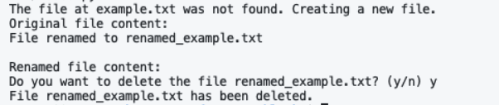

Submission Instructions
Visit https://cityuseattle.github.io/ for detailed steps.
Once you have all submission files in your original downloaded GitHub folder, go to your command line interface in Terminal and type the following commands one by one:

- git add .
- git commit -m “Submission for Module 01 – Your First and Last Name”
- git push

You may need to add “origin” or “origin master” to the last command if you have an error.
If you have GitHub Desktop, you should see your staged commits (“git add .”) in the left-hand side bar. Type in “Submission for Module 01 – Your First and Last Name]” in the commit message box and press the commit button, then the blue “push origin” button.
Go to your Classroom GitHub web page for this assignment – the same one you downloaded from – and make sure the page is refreshed. This should confirm that you submitted the correct files along with a time stamp.

